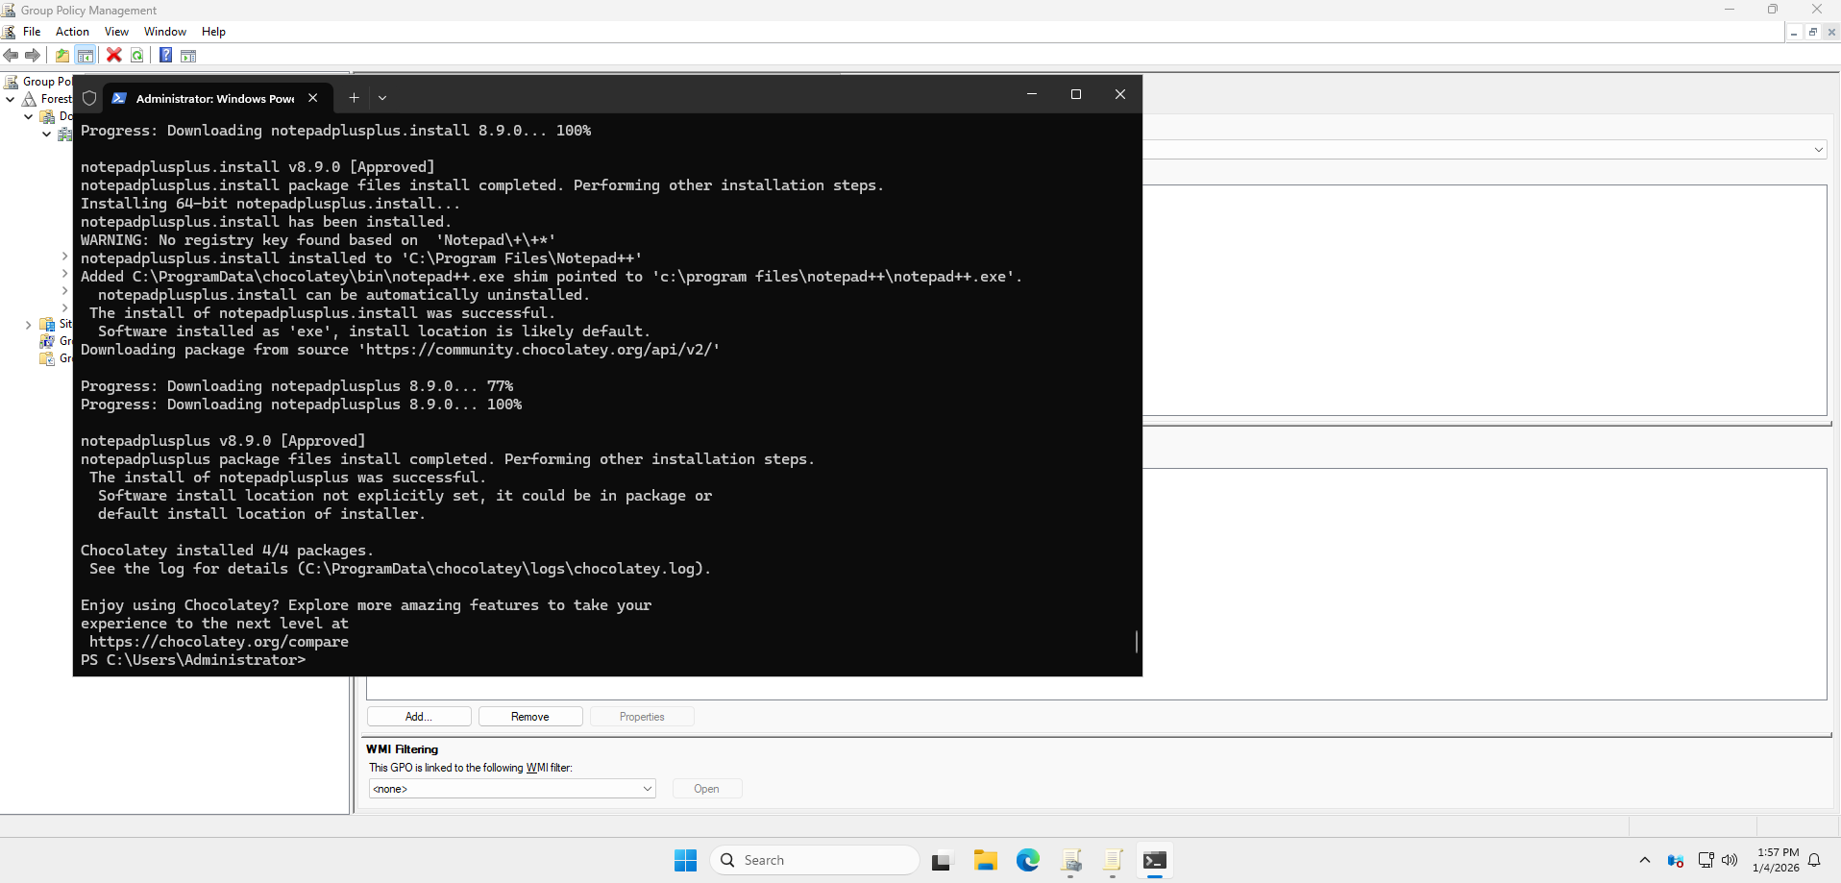 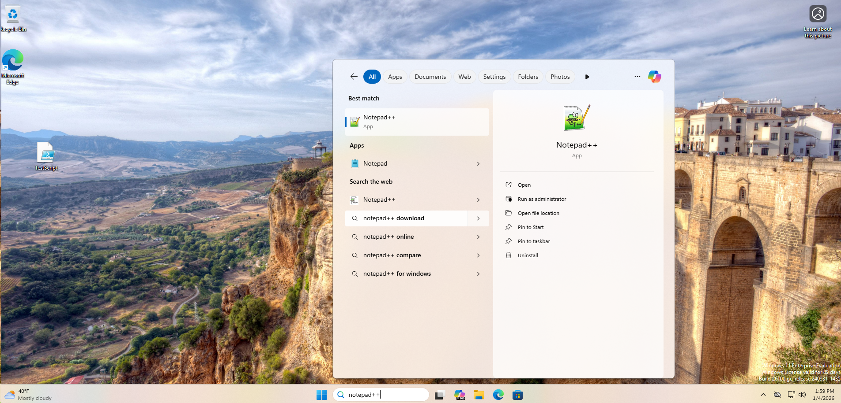
Endpoint Automation with Build Scripts
A PowerShell script was used to remotely install Notepad++ on the workstation from the Domain Controller.
PowerShell command used:
Invoke-Command -ComputerName DESKTOP-FE6V1NU -ScriptBlock {
& "C:\ProgramData\chocolatey\bin\choco.exe" install notepadplusplus -y
}
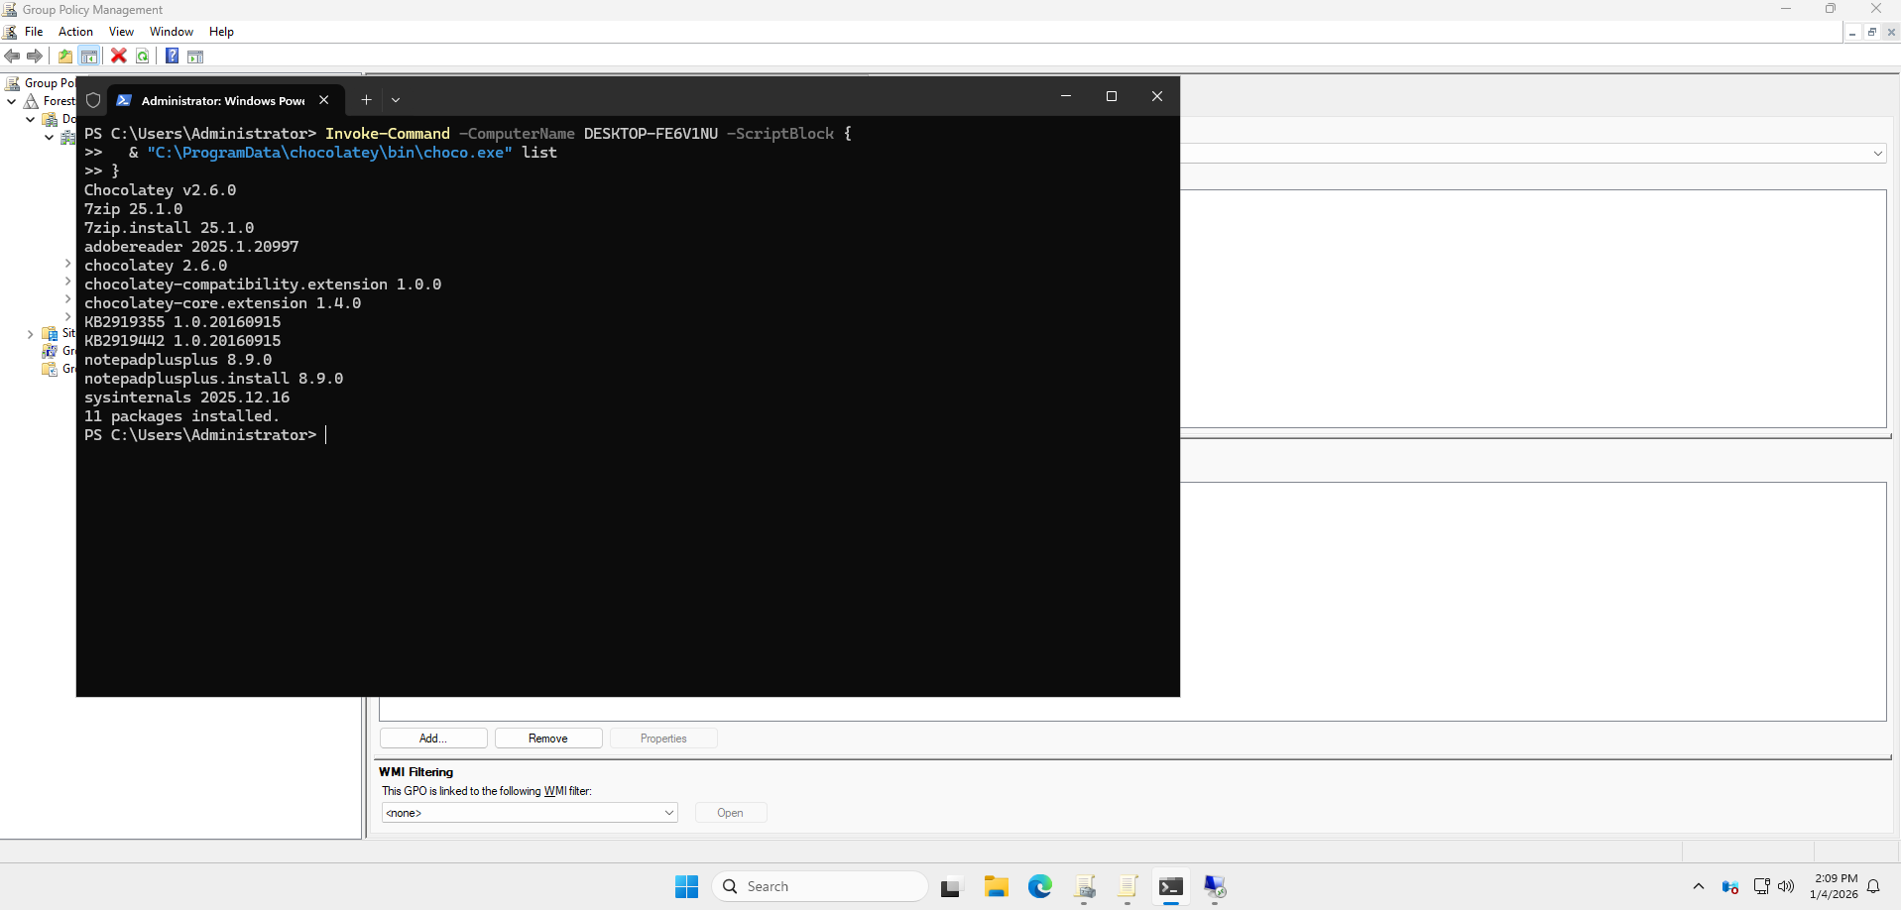
Additional Remote Software Installation
Additional software was installed remotely on the workstation, including 7-Zip, Sysinternals Suite, and Adobe Acrobat Reader.
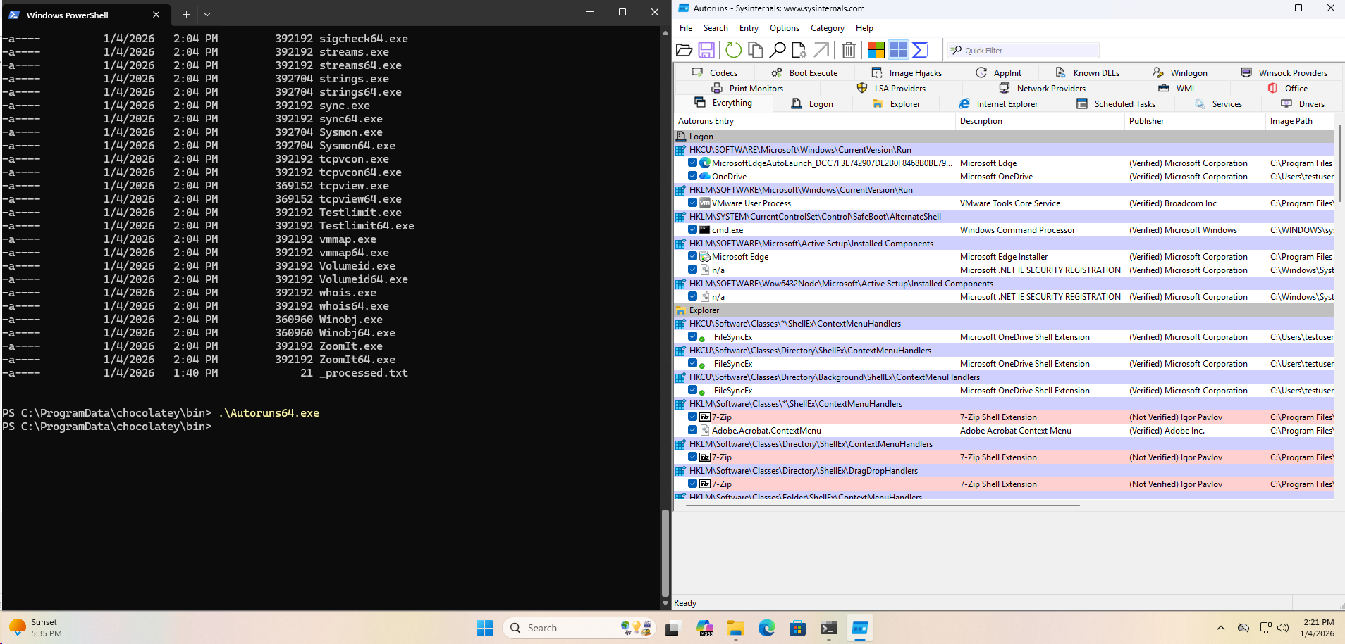
Autoruns Analysis
Autoruns was executed to identify all locations in Windows where code can automatically start or persist. This tool provides visibility into startup mechanisms and potential persistence techniques used by applications and malware.

